Via facsimile to 703-506-3266 or
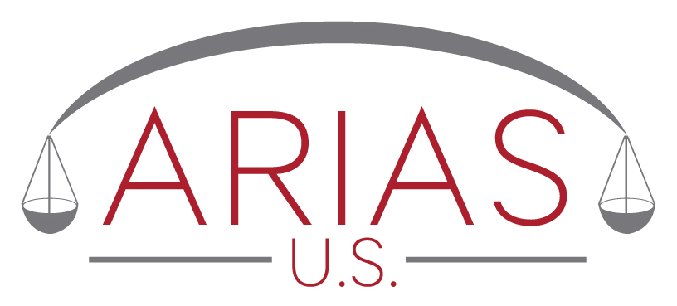
e-mail to director@arias-us.org

Sara Meier
Executive Director
ARIAS•U.S.
7918 Jones Branch Dr., Suite 300
Mclean, VA 22102

RE: Enhanced Umpire Selection Request

Dear Ms. Meier:

On behalf of _____________________ (Petitioner) and ____________________ (Respondent), parties to a pending arbitration, we request that your office forward to the undersigned a list of twelve (12) names selected at random from the ARIAS•U.S. Certified Arbitrators List, after the following filters have been applied:

- At least 15% of experience in asbestos-related fields; and
- At least 80% of experience in the U.S. market.

This request is made pursuant to the ARIAS•U.S Enhanced Umpire Selection Program ("program").

The parties to the arbitration and their representatives understand that their request for a random list and/or use of the program or umpire selection procedure (“procedure”) constitutes their agreement not to assert any claim, file any suit, or initiate any action against ARIAS•U.S., its executive director, or its officers or directors, in connection with a random list and/or the program or procedure. The request for a random list and/or use of the program or procedure also constitutes the agreement of the parties to the arbitration to jointly and severally protect, defend, indemnify, and hold harmless ARIAS•U.S., its executive director, and its officers and directors, against any and all expenses, costs, and fees of any kind in connection with any claim, action or lawsuit involving the program or procedure or a random list.

The undersigned also understand that there is no fee for use of the program.

The foregoing is submitted on behalf of the petitioner and respondent by their undersigned representatives.

For Petitioner For Respondent

By _____________________________ By ___________________________
Name: Name:
Firm: Firm:
Address: Address:
E-mail: E-mail:

