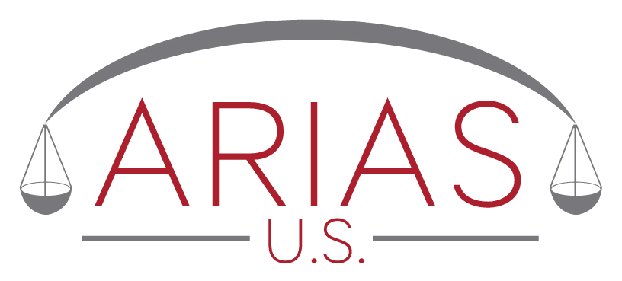
By postal mail or facsimile
Fax to 703-506-3266
E-mail to smeier@arias-us.org

Sara Meier
Executive Director
ARIAS•U.S.
7918 Jones Branch Dr., Suite 300
McLean, VA 22102
RE: Neutral Selection of Arbitration Panel

Dear Ms. Meier:

On behalf of _____________________ (Petitioner) and ____________________ (Respondent), parties to a pending arbitration, we request that your office forward to the undersigned a list of _______ names (recommended number 30) selected at random from the ARIAS•U.S. Certified Arbitrators List. This request is made pursuant to the ARIAS•U.S. Neutral Selection Procedure ("procedure").

The parties to the arbitration and their representatives understand that their request for a random list and/or use of the procedure constitutes their agreement not to assert any claim, file any suit, or initiate any action against ARIAS•U.S., its executive director, or their officers or directors, in connection with a random list and/or the procedure. The request for a random list and/or use of the procedure also constitutes the agreement of the parties to the arbitration to jointly and severally protect, defend, indemnify, and hold harmless ARIAS•U.S., its executive director, and their officers and directors, against any and all expenses, costs, and fees of any kind in connection with any claim, action, or lawsuit involving the procedure or a random list.

The undersigned also understand there is no fee for use of the procedure.

The foregoing is submitted on behalf of the Petitioner and Respondent by their undersigned representatives.

For Petitioner For Respondent

By _____________________________ By ___________________________
Name: Name:
Firm: Firm:

