ARIAS•U.S. 2019 Fall Conference
Round Pegs in Round Holes: Effectively (and Ethically) Marketing, Evaluating, and Selecting Arbitrators in a Changing World
Breakout Session

Arbitrator Use of Social Media for Marketing

Larry P. Schiffer
Squire Patton Boggs (US) LLP

With the advent of the internet and the proliferation of social media, many businesses—be they Fortune 500 Companies or solo service providers—have moved some or all of their business development and marketing efforts to cyberspace. These materials will provide an introduction to social media and give some examples of how service providers, including arbitrators, are using social media to generate business.
First, a definition. By “Social Media,” I mean internet or application-based platforms that allow users to share information, pictures and other content either directly with each other or through groups or chats or blogs or posts. Facebook is a prime example of social media. A Facebook user can post on the user’s “wall” all sorts of information about the user or can create group or a page to promote the user’s interests or activities. LinkedIn is another example of social media. LinkedIn is primarily for business, rather than personal social interaction, but also allows for posting of information or collective communication through groups. Users connect with each other to see relevant posts. YouTube, Instagram, Twitter and many other platforms also are available for users to post content.
Today, a substantial amount of social media use takes place through applications (“apps”) on smartphones rather than on computers. Every social media platform has an app that can be downloaded onto a user’s smartphone. These apps are optimized for the smaller screen of the phone, which allows users to keep up with their social media content wherever they are without having to worry about a computer. Facebook, LinkedIn, Twitter, YouTube, Instagram all have mobile apps.
Although we use the term social media, these platforms have become business platforms. Nearly every webpage for a business has a place where you can link to them via social media. So when you go to a website and see that means you can reach that business via Facebook, Instagram, LinkedIn and Twitter (in the order presented) just by clicking on those icons.
In fact, many businesses review social media posts of others to find people they want to work with and ask them to become influencers for them. For example, if you have a cute baby and you post pictures of your baby wearing a manufacturer’s product, if you mention that manufacturer in your post it is possible that the manufacturer’s social media team will reach out and ask you to work with them to promote their brand. Social media influencers can make or break start-up companies trying to reach that millennial and younger audience.
So how important and active is social media? Well, the chart below from 2018 by Gary Hayes gives you some examples of the activity that takes place on social media within just a few seconds. And the numbers have only increased since this survey.
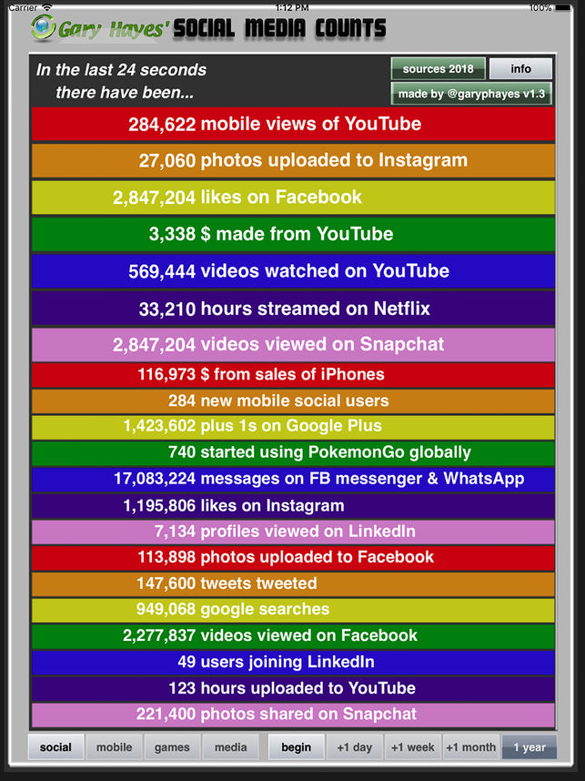
There are many social media platforms out there, but only a handful are relevant to business development by arbitrators. Others may disagree with this assessment and new platforms arrive with frequency. Who your audience is has a lot to do with what social media platform make sense to use. In the context of ARIAS, the audience is lawyers, law firms, insurance companies, reinsurance companies, brokers, third-party administrators, and others within the insurance and legal community. What that means is some of the social media platforms being used by your children or grandchildren are not really relevant to you as an arbitrator seeking to promote your practice (e.g., Snapchat, Reddit, WhatsApp).
The most useful social media platforms with widespread use and acceptability for business are the following:
LinkedIn -- www.linkedin.com
Twitter -- https://twitter.com
Instagram -- https://www.instagram.com
Facebook -- www.facebook.com
YouTube -- www.youtube.com
This list does not include the various blogging platforms that exist, which are also useful for business development through thought leadership. These include WordPress, Blogger, and Tumblr. There are also subscription services like Lexology, which allow organizations to build blogs. What’s good about blogging is that blog posts are often picked up by others are circulated further. An example of an arbitrator with a blog is international arbitrator Marc Goldstein, who has a blog called Arbitration Commentaries. http://arbblog.lexmarc.us/
There are also content aggregators that organizations subscribe to that allow that organization’s blog or other content to be reposted and recirculated on the aggregator’s platform. Examples of these include JD Supra and The National Law Review.
Out of the social media platforms listed above, the most useful professional social media platform for our purposes is LinkedIn. LinkedIn is a business social media platform that requires a user to join in order to use its services. Members of LinkedIn can post content, write articles and form groups. Set forth below are some screenshots that give you an example of what a professional profile looks like on LinkedIn.
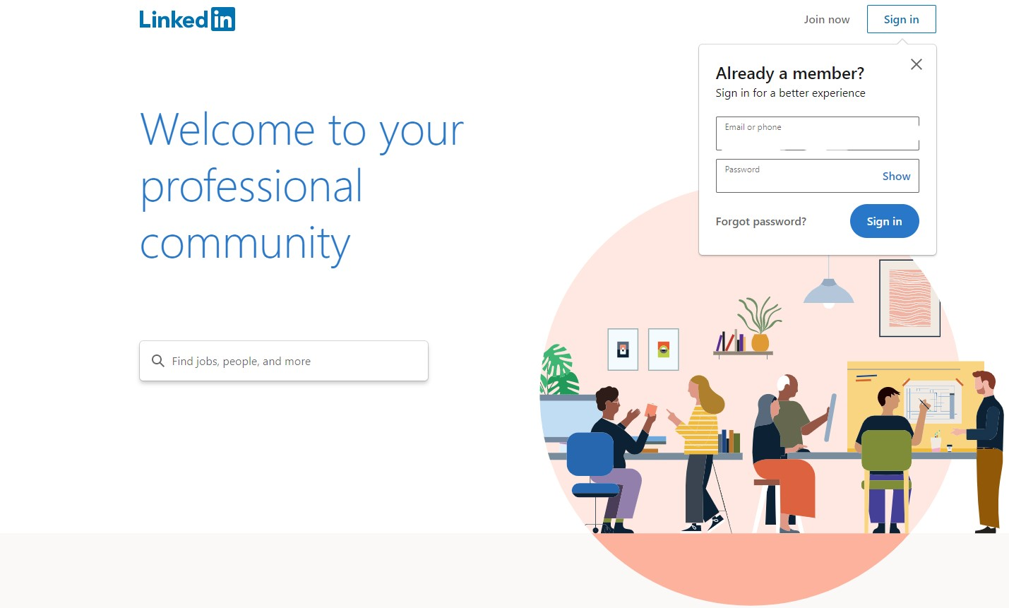

If you are not a member of LinkedIn already, this is what you will see when you go to the LinkedIn site. Just click on Join now at the top to start your membership (there is no cost for the basic membership). Once you are a LinkedIn member, you will need to create your profile and you will generate a home page will look like the image below (also known as your LinkedIn feed).
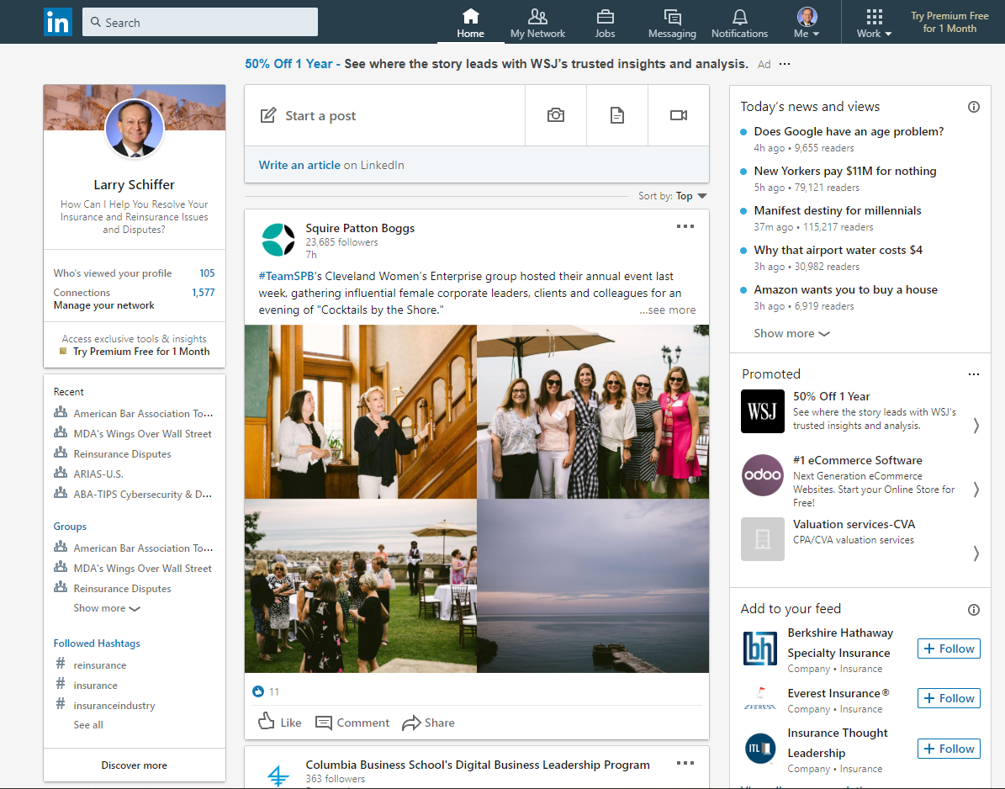

On this page you will see posts from people or businesses that you follow, groups that you have joined, hashtags that you follow, your profile information in short form, and various menus and options to search, create a post, check a group and many other things. The more people you connect with, the more groups you join and the more posts you make, the more information will appear on your feed.
For a professional, it is key to have a good headshot (taken by a professional, not your spouse) and a headline about you or your business (as you can see above, my headline is “How Can I Help You Resolve Your Insurance and Reinsurance Issues and Disputes?”). These items are part of your profile. An example of a headline used by an arbitrator on LinkedIn is: “Arbitrator and Insurance/Reinsurance Consultant.” I would recommend that arbitrator certification be added to that headline so it reads more like this: “ARIAS•U.S. Certified Arbitrator and Insurance/Reinsurance Consultant.” ARIAS certified arbitrators should add that certification statement because the headline appears on every post made. Here’s an example of what the headline line looks like in a post:
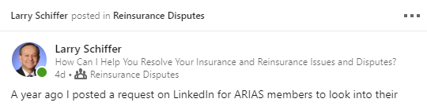
What adding the headline does is give every reader a quick snapshot of who you are and why they may want to get to know you. For an arbitrator, this is a simple way of telling a wide audience that you are available to serve on insurance and reinsurance arbitrations.
Filling out the profile in a professional way that highlights your skills and experience is imperative. It is critical not to neglect the profile, especially the headline, the “about” section where you can expand upon your headline and summarize your experience, and, of course, your work history and accomplishments. Below is part of my profile page with the drop down menu to show the categories of items you can add to your profile.
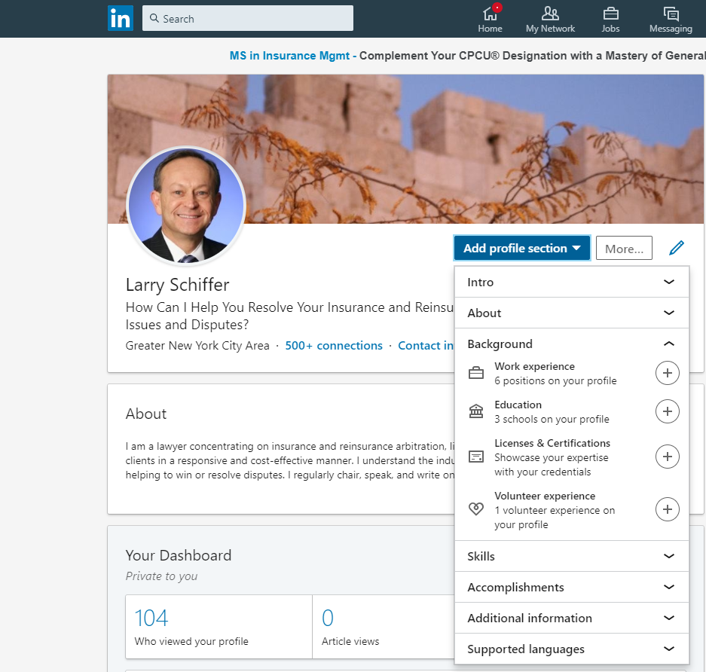

The “about” section is often neglected, but it gives you an opportunity to summarize your skills and experience. Think of it as an elevator speech. My “about” section is below.
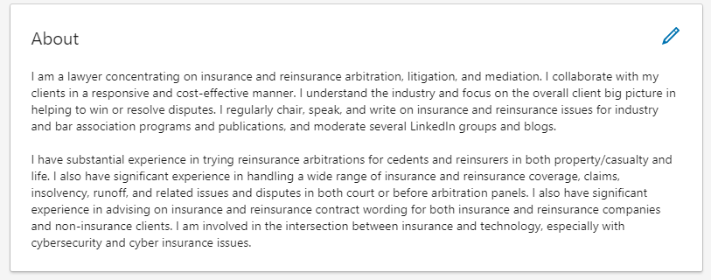
After joining LinkedIn, it is important to start connecting with other users (but be careful about who you connect with to minimize conflict issues) and to join Groups that are relevant to your interests and practice. For arbitrators, joining the various insurance and reinsurance and arbitration groups is important. There are quite a few relevant groups with different levels of activity and information. There are 192 groups involving some aspects of reinsurance (searching arbitration yields 325 group results). Here are some examples:

Reinsurance Insurance Professionals Worldwide Group • 38,477 members
The purpose of this group is to bring Reinsurance and Insurance professionals together on LinkedIn.

Insurance & Reinsurance Professionals Group • 13,212 members
A professional discussion and networking group for those involved in the insurance and reinsurance industry.

Reinsurance Professionals Group • 9,772 members
This is a group for global reinsurance professionals.

Life Reinsurance Group • 2,024 members
The life reinsurance group is a networking group for all practitioners and professionals engaged in, or with an interest in the life reinsurance industry.

Global P&C Reinsurance & Insurance Network Group • 1,940 members
Global network of Non-life re/insurance professionals. Forum to discuss, debate, suggest and comment on key themes impacting the re/insurance market.

Reinsurance Claims Group • 1,339 members
This group is a forum for the open discussion of issues and sharing of information concerning ceded and assumed reinsurance claims in the U.S. and overseas markets.

Reinsurance Disputes Group • 1,333 members
This group is for a broad based discussion of trends, issues, concerns, developments, ideas, and other items about reinsurance disputes: how to solve them, how to mediate them, how to litigate them, and how to avoid them.

Insurance and Reinsurance Arbitration and Mediation Group • 964 members
This group is intended for insurance and legal professionals to come together and address issues germane to resolving complex insurance and reinsurance coverage disputes through alternative dispute resolution.
Joining a Group and connecting with other LinkedIn members is nice, but if you want to develop business you have to do more. Keeping in mind the Code of Conduct, Canon IX, “Arbitrators shall be truthful in advertising their services and availability to accept arbitration appointments,” arbitrators are free to post articles, comments, links to blog posts and other materials relevant to their practice. Just remember, you may have to disclose any articles and your social media profile may become relevant in the selection process.
Whether you as an arbitrator want to participate professionally on other social media channels is a personal choice. Twitter provides the opportunity to interact with others using 280 character messages. Nearly all insurance and reinsurance companies have Twitter “handles” or user names. Nearly all government officials have Twitter accounts. Twitter is a good way to circulate articles and blog posts beyond LinkedIn or a personal email list. Below is a snapshot of my Twitter profile page showing how I leverage my blog posts.
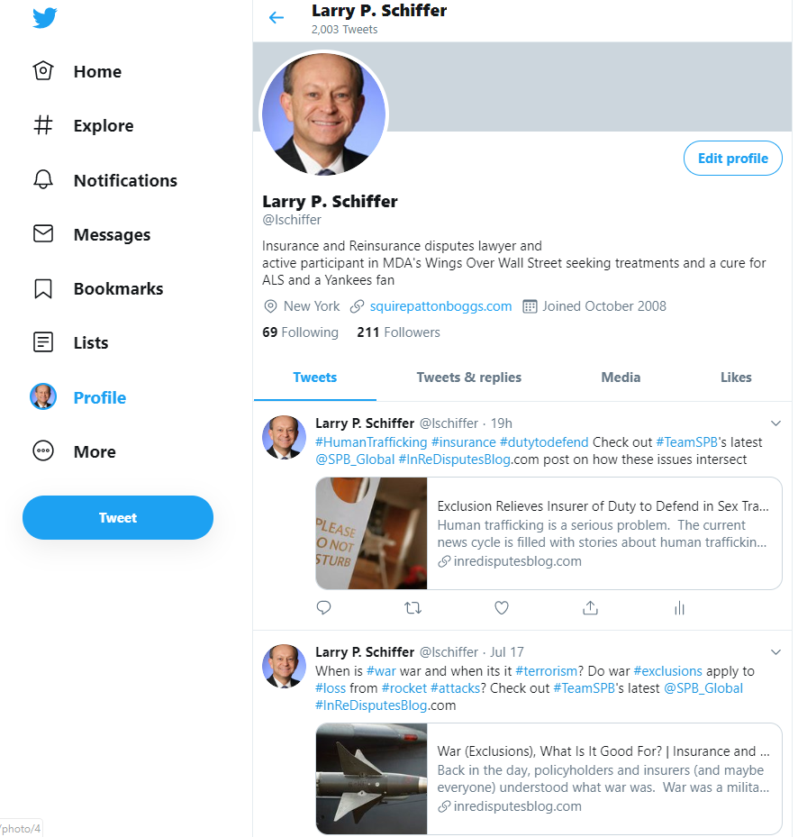

While many consumer businesses, including most law firms, are using Facebook, Instagram and YouTube, the utility of these platforms for arbitrators is limited unless an arbitrator plans to post with frequency. For example, if you want to market yourself by posting short videos discussing insurance, reinsurance or arbitration issues, YouTube would be the place to do so.
Nevertheless, given the nature of these platforms it is less likely that buyers of arbitration services will be looking to these platforms to learn about arbitration services. A search for arbitrator or reinsurance on these platforms yields some results, but certainly not active participation by insurance and reinsurance arbitrators seeking to use those platforms for marketing. Keep in mind, however, that if you have a personal or professional presence on Facebook, Instagram or YouTube, you can bet that counsel will be looking at your profile.
Social media is another tool in the arbitrator toolbox for generating arbitration business. The more tech savvy the company and the law firm, the more likely they will expect their arbitrators to be present on social media. Think it through and do what is comfortable for you, but don’t discount the potential economic value of using social media to help enhance your arbitration practice.

